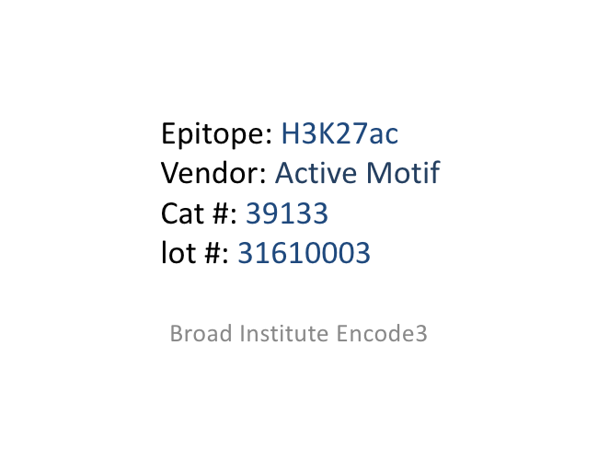

Epitope: H3K27ac Vendor: Active Motif Cat #: 39133 lot #: 31610003

Broad Institute Encode3

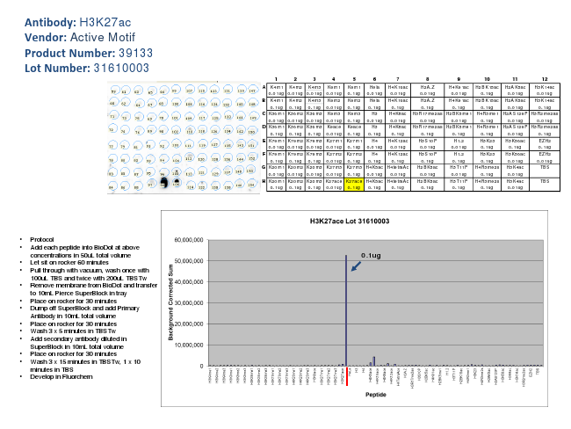

**Antibody: H3K27ac Vendor: Active Motif Product Number: 39133 Lot Number: 31610003**

• Protocol

• Add each peptide into BioDot at above concentrations in 50uL total volume

• Let sit on rocker 60 minutes

• Pull through with vacuum, wash once with 100uL TBS and twice with 200uL TBSTw

• Remove membrane from BioDot and transfer to 10mL Pierce SuperBlock in tray

• Place on rocker for 30 minutes

• Dump off SuperBlock and add Primary Antibody in 10mL total volume

• Place on rocker for 30 minutes

• Wash 3 x 5 minutes in TBSTw

• Add secondary antibody diluted in SuperBlock in 10mL total volume

• Place on rocker for 30 minutes

• Wash 3 x 15 minutes in TBSTw, 1 x 10 minutes in TBS

• Develop in Fluorchem

1 2 3 4 5 6 7 8 9 10 11 12 A K4m1 K4m2 K4m3 K9m1 K9m1 Hela H4K16ac H2A.Z H4K91ac H2BK15ac H2AK5ac H3K14ac

0.01ug 0.01ug 0.01ug 0.01ug 0.1ug 0.01ug 0.01ug 0.01ug 0.01ug 0.1ug 0.01ug 0.01ug B K4m1 K4m2 K4m3 K9m2 K9m2 Hela H4K16ac H2A.Z H4K91ac H2BK15ac H2AK5ac H3K14ac

0.1ug 0.1ug 0.1ug 0.01ug 0.1ug 0.1ug 0.1ug 0.1ug 0.1ug 0.1ug 0.01ug 0.1ug C K36m1 K36m2 K36m3 K9m3 K9m3 H3 H4K8ac H3R17me2as H2BK5me1 H4R3me1 H2AS129P H3R2me2as 0.01ug 0.01ug 0.01ug 0.01ug 0.1ug 0.01ug 0.01ug 0.01ug 0.01ug 0.1ug 0.01ug 0.01ug D K36m1 K36m2 K36m3 K9ace K9ace H3 H4K8ac H3R17me2as H2BK5me1 H4R3me1 H2AS129P H3R2me2as 0.1ug 0.1ug 0.1ug 0.01ug 0.1ug 0.1ug 0.1ug 0.1ug 0.1ug 0.1ug 0.01ug 0.1ug E K79m1 K79m2 K79m3 K27m1 K27m1 H4 H4K12ac H3S10P H1.2 H3K23 H3K56ac EZH2 0.01ug 0.01ug 0.01ug 0.01ug 0.1ug 0.01ug 0.01ug 0.01ug 0.01ug 0.1ug 0.1ug 0.1ug F K79m1 K79m2 K79m3 K27m2 K27m2 H4 H4K12ac H3S10P H1.2 H3K23 H3K56ac EZH2

0.1ug 0.1ug 0.1ug 0.01ug 0.1ug 0.1ug 0.1ug 0.1ug 0.1ug 0.1ug 0.01ug 0.01ug G K20m1 K20m2 K20m3 K27m3 K27m3 H4K5ac H4tetraAc H2BK5ac H3T11P H4R3me2s H3K4ac TBS

0.01ug 0.01ug 0.01ug 0.01ug 0.1ug 0.01ug 0.01ug 0.01ug 0.01ug 0.1ug 0.01ug H K20m1 K20m2 K20m3 K27ace K27ace H4K5ac H4tetraAc H2BK5ac H3T11P H4R3me2s H3K4ac TBS

0.1ug 0.1ug 0.1ug 0.01ug 0.1ug 0.1ug 0.1ug 0.1ug 0.1ug 0.1ug 0.01ug

0.1ug